# How loud is a string?

## Introduction

I enjoy playing songs on piano. However, I have noticed that while it is easy to play louder sound, playing quietly have always been a challenge. This turned me curious of the relationship between the loudness of the sound and the amount of force that I apply to it.

## Experimental variables

The loudness of a sound is determined by the intensity of the sound wave and the energy which it contains..

## The Experiment

## Predicting the relationship

### Variables

|  |  |  |
| --- | --- | --- |
| Variable | Meaning | Unit |
| $$I$$ | Intensity | $$W/{m^{2}}$$ |
| $$p$$ | Sound pressure | $$Pa$$ |
| $$v$$ | Particle velocity | $$m/s$$ |
| $$ω$$ | Angular frequency | $${rad}/s$$ |
| $$a$$ | Amplitude (particle displacement) | $$m$$ |
| $$μ$$ | Density of medium in which sound is traveling | $${kg}/{m^{3}}$$ |
| $$c$$ | Speed of wave (sound) | $$m/s$$ |
| $$f$$ | frequency | $$Hz$$ |
| $$π$$ | Ratio of circumference to diameter of a circle |  |
| $$F_{t1}$$ | Original tension of the string | $$N$$ |
| $$F_{t2}$$ | Tension of the string at equilibrium | $$N$$ |
| $$F_{a}$$ | Force of the striking object | $$N$$ |
| $$F_{v}$$ | Vertical component of the tension of the string | $$N$$ |
| $$x$$ | Change in length of the string after tension is applied | $$m$$ |
| $$k$$ | Spring constant of the string | $$N/m$$ |
| $$l_{o}$$ | Original length of the string | $$m$$ |
| $$l_{n}$$ | Current length of the string | $$m$$ |
| $$P_{no gain}$$ | Power output of the microphone without gain | $$V$$ |
| $$σ$$ | sensitivity | $$V/{Pa}$$ |
| $$P_{output}$$ | Actual output voltage of the microphone | $$V$$ |
| $$γ$$ | Gain of the microphone | $$V$$ |
| $$P_{dBV}$$ | Measured output of microphone | $$V$$ |

### Deriving the formula

The loudness of sound is dependent on its intensity, which can be expressed as: $I=pv=\frac{1}{2}ω^{2}a^{2}μc$

Since angular frequency is just change in angle per second: ,

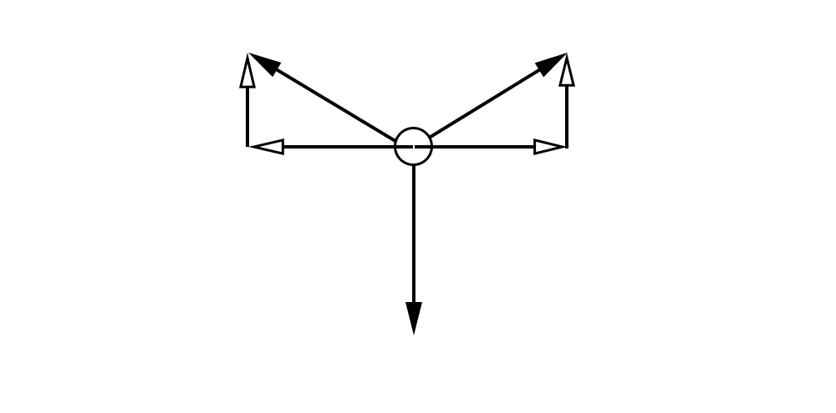

The amplitude is related to the tension force and the force pushing the string

Since at the maximum displacement, the system would be in equilibrium,

${2F}_{v}=F_{a}$, which means that $F_{t2}=\sqrt{{F_{t1}}^{2}-{(\frac{F_{a}}{2})}^{2}}$

Since $F_{t2}$ will be the final force on the string, the string will extend $x=\frac{F_{t2}}{k}=\frac{\sqrt{{F_{t1}}^{2}-{(\frac{F_{a}}{2})}^{2}}}{k}$ m

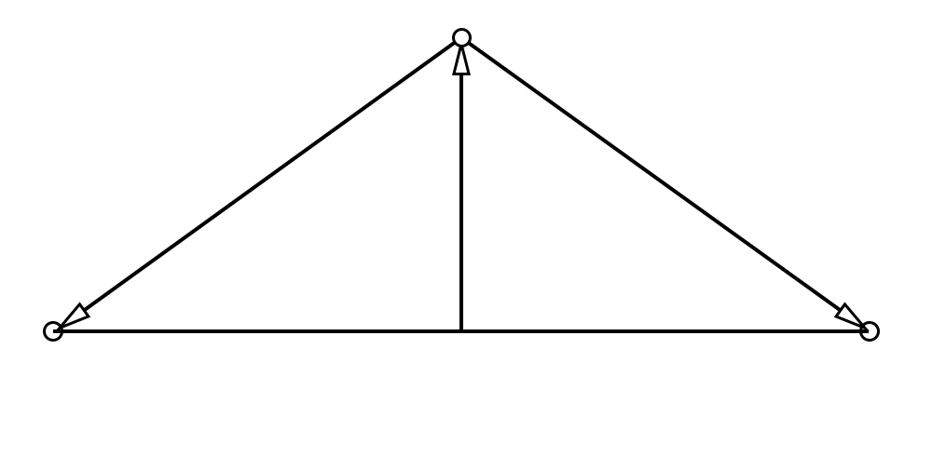

=>

Therefore $I={2π^{2}f^{2}a}^{2}μc={2π^{2}f^{2}\sqrt{({\frac{l_{o}}{2})}^{2}+{(\frac{l_{o}k+\sqrt{{F_{t1}}^{2}-{\left(\frac{F_{a}}{2}\right)}^{2}}}{2k})}^{2}}}^{2}μc=2π^{2}f^{2}[({\frac{l_{o}}{2})}^{2}+{\left(\frac{l_{o}k+\sqrt{{F_{t1}}^{2}-{\left(\frac{F_{a}}{2}\right)}^{2}}}{2k}\right)}^{2}]μc$

The sound pressure level can be determined by the power that the microphone produced divided by the sensitivity

$$p=\frac{P_{no gain}}{σ}=\frac{\frac{P_{output}}{γ}}{σ}=\frac{P_{output}}{γσ}$$

Also, as the measured power is in decibel $P_{dBV}=10log⁡(\frac{P_{output}}{1})$ => $P_{output}={10}^{\frac{P_{dBV}}{10}}$

As $v=ωa=2πfa$, therefore: $I=pv={10}^{\frac{P_{dBV}}{10}}∙2πfa$

Now, equal the two equations for intensity: $2π^{2}f^{2}[\left({\frac{l_{o}}{2})}^{2}+{\left(\frac{l_{o}k+\sqrt{{F_{t1}}^{2}-{\left(\frac{F_{a}}{2}\right)}^{2}}}{2k}\right)}^{2}\right]μc={10}^{\frac{P_{dBV}}{10}}∙2πfa$

Canceling some terms: $πfμc\sqrt{({\frac{l_{o}}{2})}^{2}+{(\frac{l_{o}k+\sqrt{{F_{t1}}^{2}-{\left(\frac{F_{a}}{2}\right)}^{2}}}{2k})}^{2}}={10}^{\frac{P_{dBV}}{10}}∙a$